**RECONCILIATION**

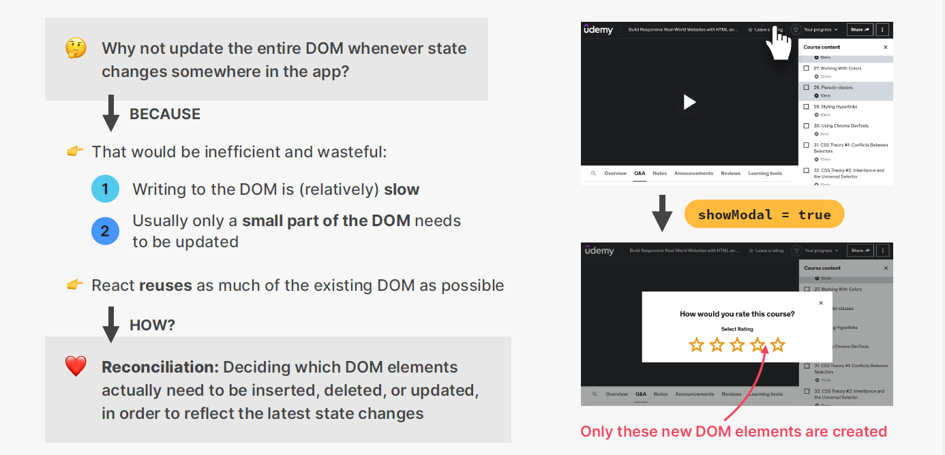

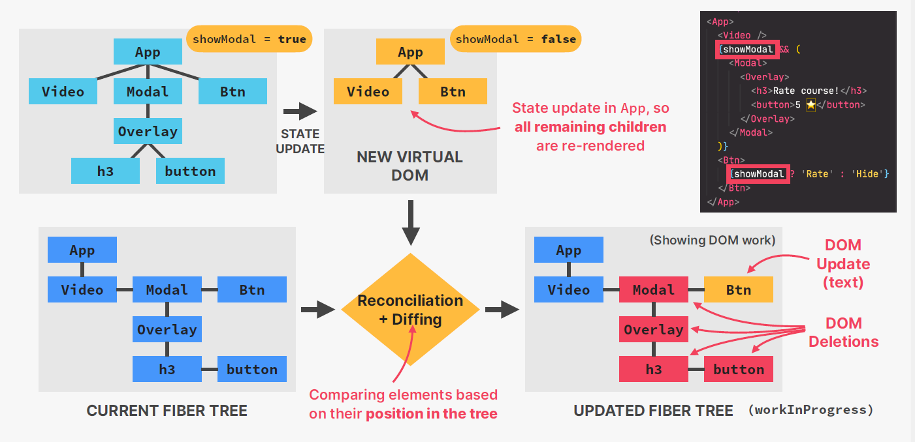

Reconciliation in React refers to the process of updating the user interface to reflect changes in the underlying data, such as changes in component state or props. React uses a diffing algorithm during the reconciliation process to efficiently determine the minimal set of updates needed to transition from the current state of the UI to the desired state.

**Do you find it helpful?**

**Let me know down in the comments**



[](https://www.linkedin.com/in/anubhav-gupta-b68946132/)

**Click To Follow For More On LinkedIN**